**Introduction to the Thonny IDE**

Now that we have wired up our circuit, how do we get it to work?

We need a piece of software, called the IDE (Integrated Development Environment), to enter our instructions (aka code, program, scripts) to instruct the Raspberry Pi to work our circuit.

For this course, we will be using a software that comes with Raspberry Pi called **Thonny.**

To start Thonny, click on the Raspberry Pi Start button.

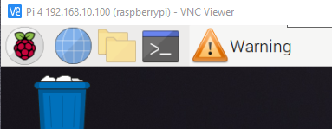

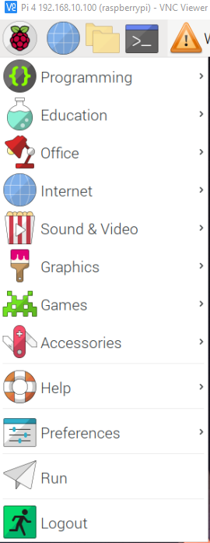 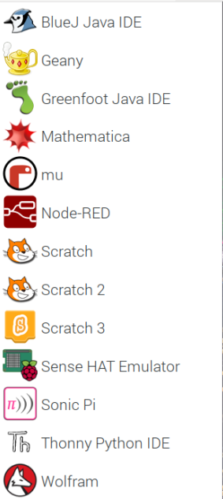

2-Click Thonny

Python IDE

1-Click Programming

The Thonny IDE opens.

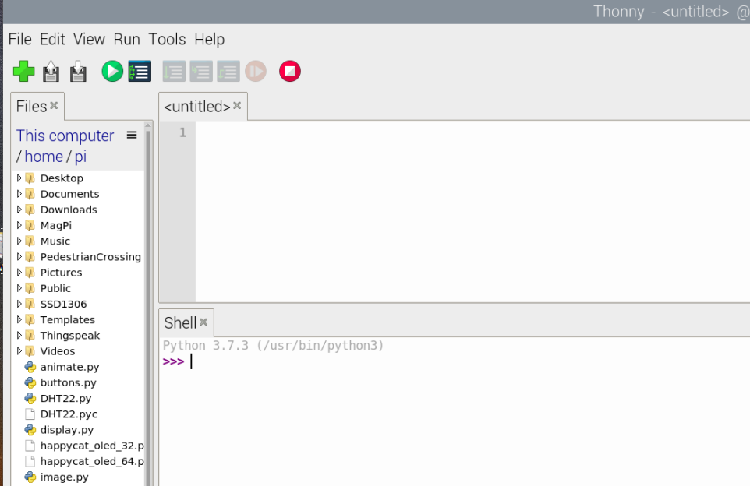

SHELL / REPL

EDITOR

REPL = Read-Eval-Print Loop

We use the Shell / REPL area to test our code. You will see three chevrons symbols like this >>>. The codes that are entered here will not be saved and will disappear once you exit Thonny

If we want our codes to be save permanently, we will have to type them into the Editor instead. These codes can then be saved into python file. It will have a .py extension. The codes will not disappear when you exit Thonny.

When you open Thonny Program again the codes which you had saved into a python file will be visible. You can then recall it into the editor to run or edit it.

We can now put come codes into our SHELL area to test our circuit.

Please follow carefully what I am showing you on the screen.